Hello Splunkers, In this blog I will discuss How to get data through REST APIs in your Splunk.

Step-1

First you have to download an app named “REST API Modular Input ’’ from Splunkbase

URL : <https://splunkbase.splunk.com/app/1546/>

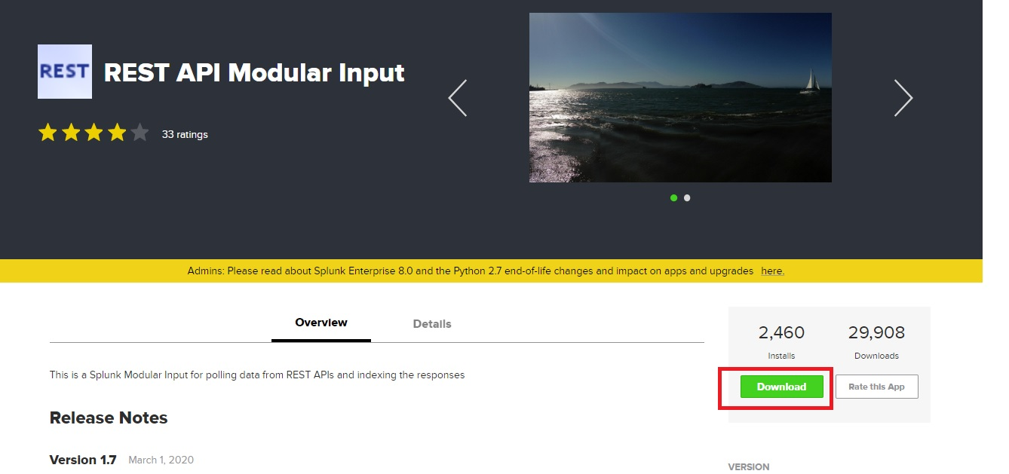

Step-2

Once it downloaded, now open your Splunk and go to Manage Apps

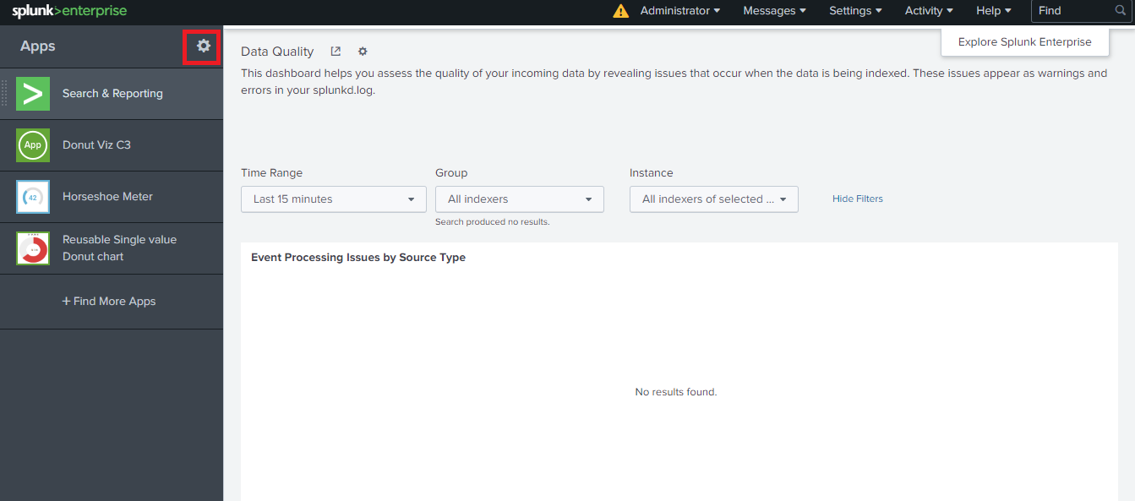

Step -3

Now select “ Install app from file” and select the app file that you just downloaded

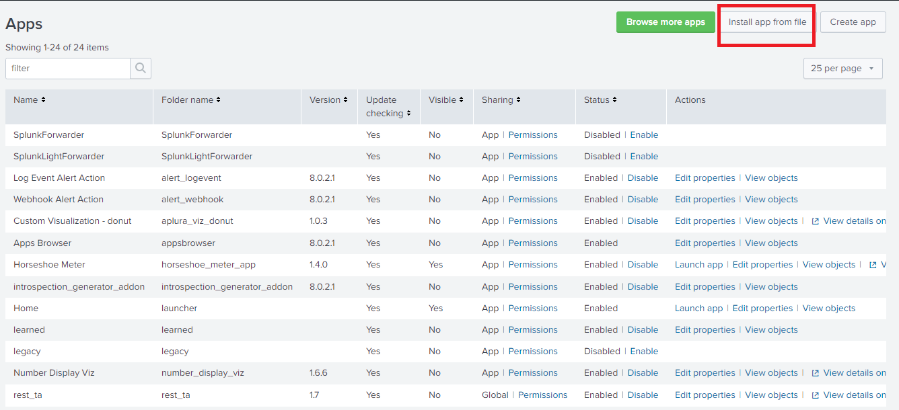

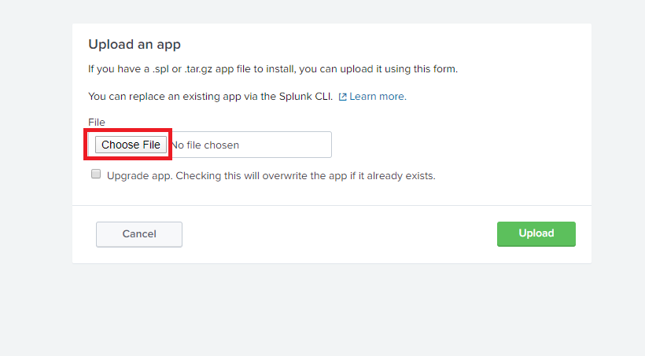

After that select upload.

Step-4

Once your app is installed , now goto Setting and then Data Inputs

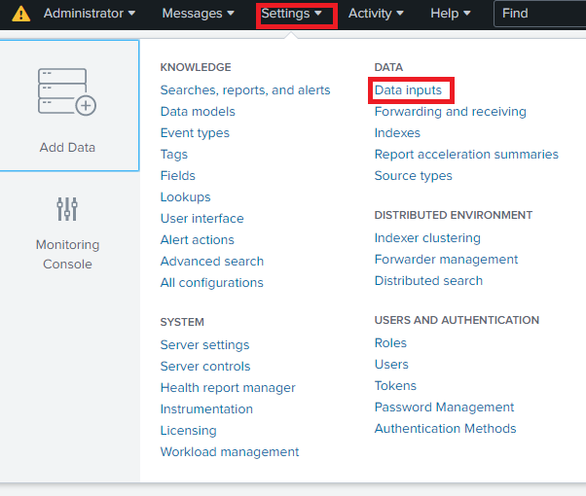

After that choose “REST” from local inputs

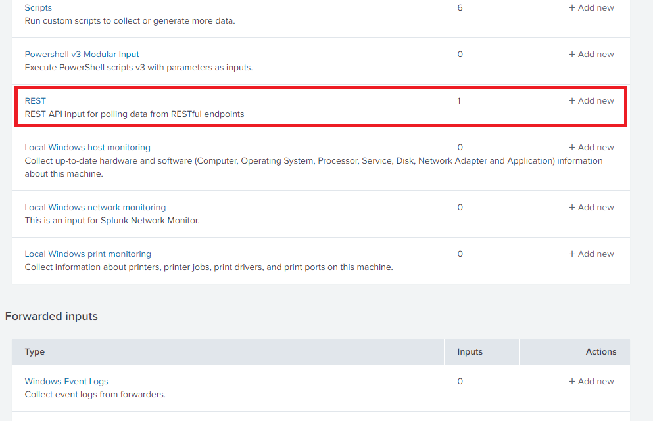

Step -5

Now you will get option to add New API and choose New

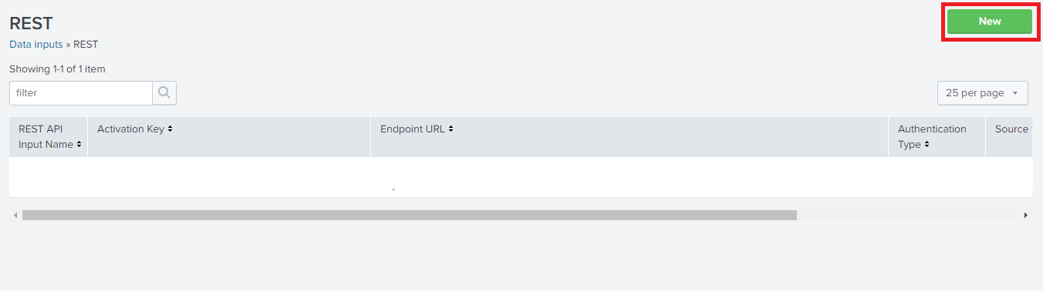

Step -6

Here you have to fill information about your API. Fill it carefully and save it.

All relevant information you will get from respective API website.

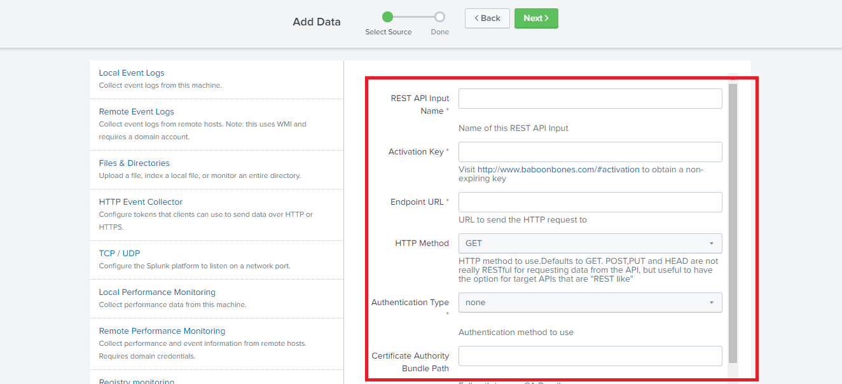

Step -6

Now open your search and reporting app and there mention index name and sourcetype and search.

In my case it looks like -

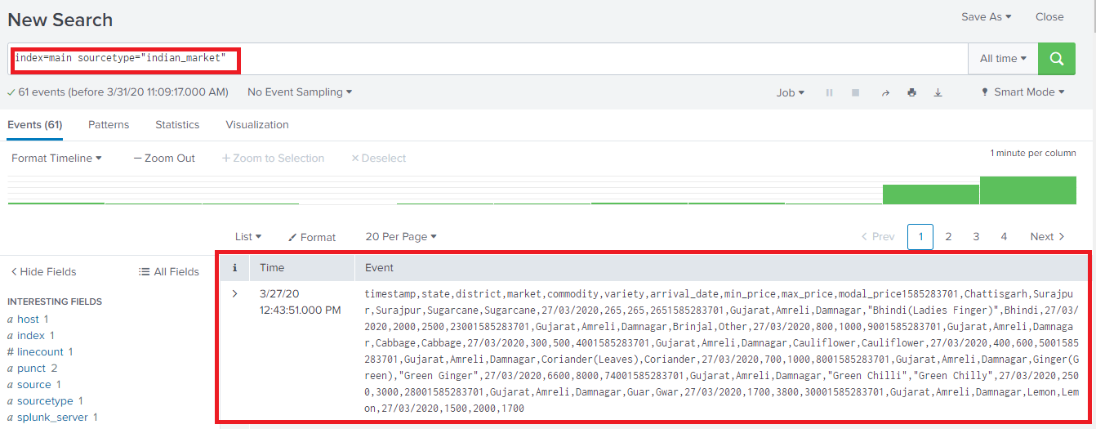

Now you will able to see data that is coming through REST API.

Happy Splunking :)